DETAILED REPORT

V-GUARD INDUSTRIES LTD – BIG IDEA TECH DESIGN COMPETITION 2026

Team Name: [Team ID]_Codey Tingle
Team Members (Full Name)
1) Ayush Manoj Garg
2) Eshan Shukla

3) Tanay Chaplot

Number of words: 4568 Date of Submission: 28 August 2026

Synopsis
India's homes still run on unreliable power, and the home inverter with its battery is the lifeline that keeps lights, refrigeration, connectivity and medical devices alive. Yet even today's Wi-Fi enabled inverters remain reactive: they report the present state but cannot predict failure, understand load, or decide for themselves. Batteries therefore die without warning, often mid-blackout; backup drains on non-essential loads; and warranty is a dispute rather than a service. V-Guard Sentinel closes this gap by embedding a low-cost, on-device AI Core inside the inverter that predicts its battery's Remaining Useful Life weeks in advance, autonomously protects critical loads during an outage, coaches energy use, and detects grid disturbances - all offline, with no dependence on the internet. Crucially, the entire installed base improves together through privacy-preserving federated learning, so accuracy compounds with V-Guard's scale into a moat competitors cannot rebuild. This report elaborates the Phase-2 concept into an engineering-grade design: the physics that makes battery degradation measurable and therefore learnable; a system and hardware architecture built around galvanic isolation and proven TinyML silicon; the machine-learning method stack for state-of-health and remaining-useful-life estimation, with an honest account of the lead-acid data gap and prediction limits; the autonomous load-prioritisation logic; and a deployable, privacy-first federated-learning pipeline. It defines the electrical, computational, model and product parameters to be specified, a software-led prototype and validation plan, the applicable Indian and international standards, an itemised bill of materials with a candid incremental-versus-standalone cost analysis, and the market, sustainability and business case. Throughout, the design is deliberately scoped to the boundary between what is deployable today and what remains a research target, because credibility, not hype, is what turns an intelligent product into a trusted one. Sentinel reframes V-Guard from the company that protects India's power into the intelligence layer the Indian home runs on.

Table of Contents
1. Introduction 4
2. Problem Context and Motivation 4
2.1 India's power-reliability gap 4
2.2 The battery as the silent point of failure 4
2.3 Why degradation is predictable, and why today's products miss it 5
2.4 The cost of the status quo 5
3. Proposed Solution: V-Guard Sentinel 5
4. System Architecture 6
5. Hardware Design of the AI Core 7
5.1 Compute 7
5.2 Isolated sensing front-end 7
5.3 Actuation, power and mechanical 8
5.4 Cost: the incremental-versus-standalone reality 9
6. Engine 1: Predictive Battery Health and Remaining Useful Life 9
6.1 Estimation stack 10
6.2 Data strategy and the lead-acid gap 11
6.3 On-device feasibility 12
6.4 Honest lead-time framing 13
7. Engine 2: Habit-Learning Autopilot and Load Prioritisation 13
8. Engine 3: Energy Coach and Grid Shield 15
9. Engine 4: Federated Fleet Intelligence 16
10. Key Parameters and Performance Targets 17
11. Prototype and Validation Plan 17
12. Standards, Safety and Compliance 18
13. Feasibility and Manufacturing 18
14. Business Value and Market Opportunity 20
15. Sustainability and Social Impact 20
16. Competitive Differentiation 20
17. Risks and Mitigations 21
18. Roadmap and Vision 21
References 22

1. Introduction
The Big Idea Tech 2026 theme asks how V-Guard moves from smart products to intelligent products. Our Phase-2 submission proposed V-Guard Intelligence: a low-cost, on-device AI Core that lets each V-Guard product predict its own failures, learn its owner's habits, and act autonomously, with the whole installed base improving together through privacy-preserving federated learning, all working offline. The flagship is V-Guard Sentinel, an intelligence upgrade to the home inverter and its battery. This detailed report is a faithful continuation of that proposal - the concept is unchanged - elaborated into an engineering-grade design. It covers the problem physics, the system and hardware architecture, the machine-learning methods and their honest limits, the parameters to be defined, a prototype and validation plan, standards and safety, unit economics, and the rollout. A deliberate thread runs through it: we separate what is deployable today from what is a research target, because the report is read by engineers, and credibility is the whole game.
2. Problem Context and Motivation
2.1 India's power-reliability gap
Independent surveys place the lived experience of Indian households far below official feeder averages. An estimated 85% of households face outages daily and 37% experience two to eight hours of outage per day [1]; one in three households suffers a blackout, low-voltage or appliance-damage event within any single month [2]. Government figures showing roughly 22.6 hours per day of rural supply conceal the evening collapse, when rural supply between 5 and 11 PM averages only about 4.7 hours [3]. Household voltage routinely swings between 180 V and 270 V against a 230 V nominal. For tens of millions of homes the inverter and battery are therefore not a convenience but critical infrastructure.
2.2 The battery as the silent point of failure
The tubular lead-acid battery, still around half of the Indian inverter-battery market, is the component that strands users. Its failure is never truly sudden; it is the end-point of measurable, months-long degradation driven by irreversible sulphation from chronic undercharge, positive-grid corrosion, water loss and dry-out, active-material shedding, and acid stratification [4]. Lithium-ion batteries degrade by different mechanisms - solid-electrolyte-interphase growth, and lithium plating under cold, fast charge - but the principle holds: degradation is progressive and observable [5]. The single most important stressor in India is temperature: lead-acid life roughly halves for every 10 degrees Celsius above 25 [6], so a battery rated for ten years at 25 C may last barely two-and-a-half in a 41 C summer. This is precisely the environment V-Guard sells into, and precisely why proactive health management matters here more than anywhere.
2.3 Why degradation is predictable, and why today's products miss it
Each ageing mechanism leaves an electrical fingerprint an inverter can observe: rising internal resistance, worsening voltage sag under load, declining charge acceptance and coulombic efficiency, and shifts in the rested open-circuit-voltage curve. Internal-resistance rise is the primary online state-of-health proxy, and charge-acceptance decline is a cheap, high-information lead-acid signal [4][6]. No single signal uniquely identifies a mechanism, but their combination tracks health closely (Exhibit 5). Today's inverters, even Wi-Fi models, measure at best the present state; none forecast the trajectory. So the four unmet needs are foresight of failure, load intelligence during outages, energy insight as time-of-use tariffs arrive, and proactive rather than reactive service. V-Guard, founded in 1977 to solve exactly Indian power unreliability, manufactures its own batteries, has taken a 30.35% stake in a battery-technology company, and has opened a 120-crore Kochi innovation campus [25]; no competitor is better placed to close this gap.
2.4 The cost of the status quo
The status quo is expensive in ways that are easy to overlook. A battery that fails a year early is not only a replacement cost to the household but, during the flat-warranty window, a direct cost to V-Guard; a blackout that outlasts a mismanaged battery spoils refrigerated food and interrupts study, work and medical routines; and voltage excursions quietly shorten the life of every appliance in the home. Because none of today's inverters convert the data they already sense into foresight, this recurring loss is simply absorbed by consumers and manufacturers alike. Intelligence embedded in the product, rather than bolted on through an app, is what turns this sunk cost into avoided cost, and it is the economic core of the case for Sentinel.
3. Proposed Solution: V-Guard Sentinel
Sentinel is an intelligence layer, not a new gadget. A compact AI Core - a microcontroller with a neural accelerator plus a small sensor set - is embedded in new inverters and offered as a retrofit module for the installed base. It runs four on-device engines and participates in a privacy-preserving federated-learning loop (Exhibit 1). Engine 1, Predictive Health and Longevity, estimates true battery state-of-health and predicts a remaining-useful-life window, flags degrading internals early, and applies an adaptive charge-and-thermal policy to extend life; a tamper-proof health-log turns warranty into a data-backed, one-tap process. Engine 2, the Habit-Learning Autopilot, learns the home's load and outage patterns and, during a blackout, autonomously protects critical loads while shedding the rest. Engine 3, Energy Coach and Grid Shield, discloses where power goes and detects grid disturbances for appliance protection. Engine 4, Federated Fleet Intelligence, lets every unit contribute encrypted model improvements so the shared model sharpens as the fleet grows. The same AI Core extends across pumps, stabilisers and water heaters, turning a portfolio of smart products into one intelligent, connected home.
4. System Architecture
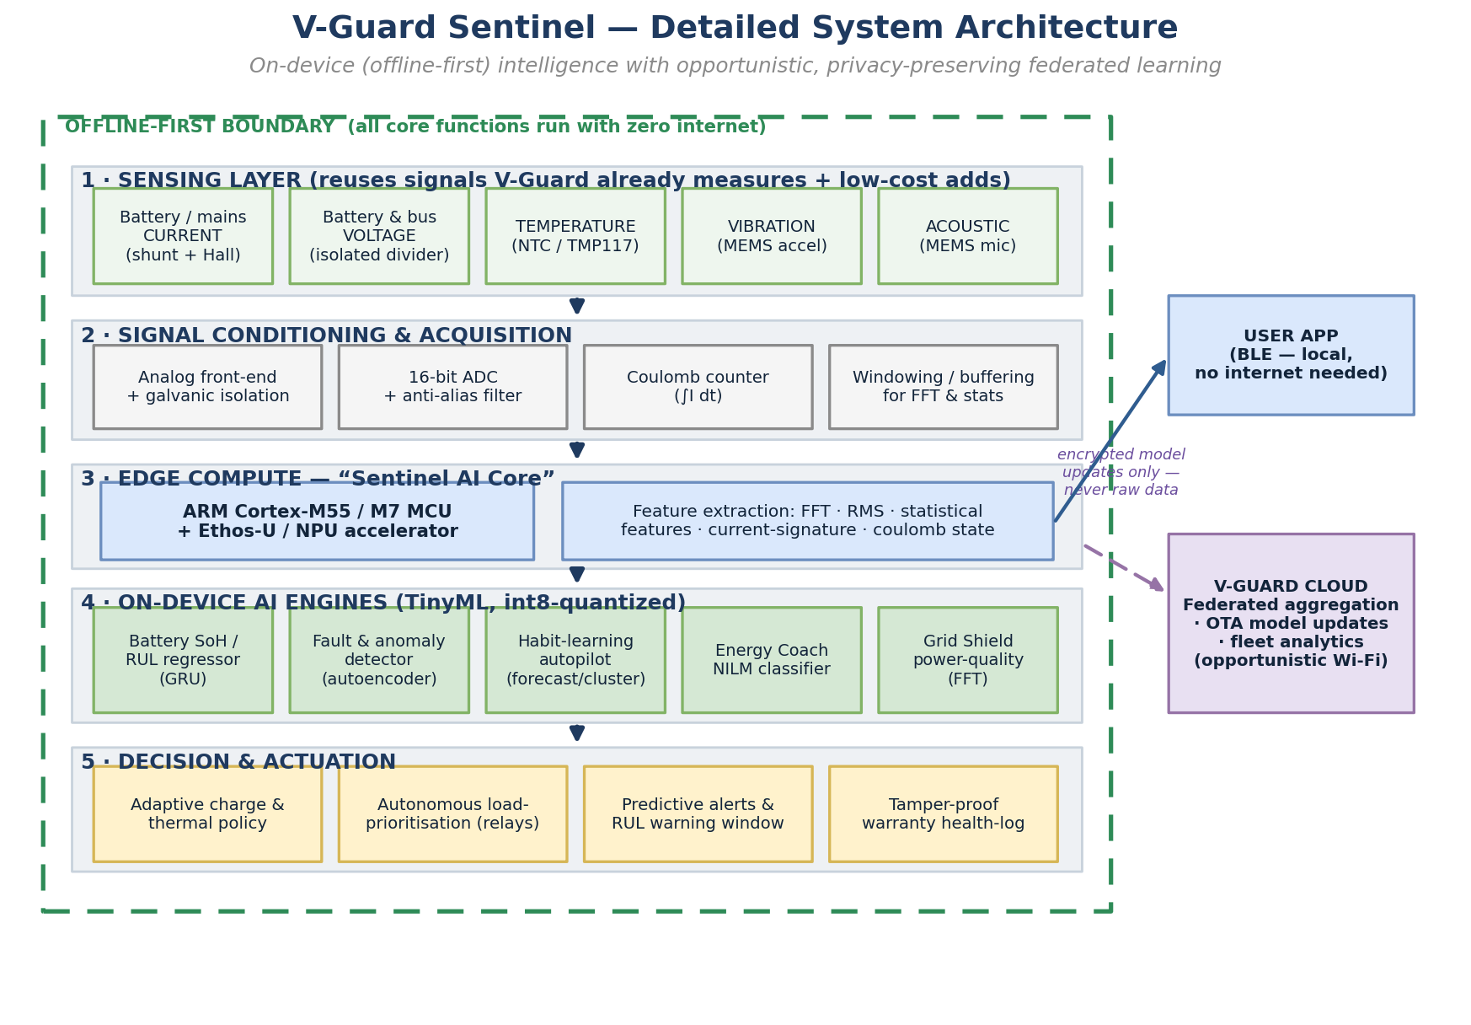
Exhibit 1. V-Guard Sentinel detailed system architecture: existing inverter sensors feed on-device TinyML engines that drive autonomous actions; only encrypted model updates leave the home. All core functions run offline.
Sentinel is organised as five on-device layers inside an offline-first boundary, with opportunistic links to a phone app over Bluetooth Low Energy and to the V-Guard cloud over Wi-Fi. The sensing layer captures current (shunt and Hall), isolated voltage, temperature, vibration and acoustics. The signal-conditioning layer provides the analog front-end, galvanic isolation, a high-resolution ADC, anti-alias filtering, a coulomb counter, and windowed buffers for FFT and statistics. The edge-compute layer is the AI Core itself. The AI-engine layer hosts the quantised TinyML models, and the decision-and-actuation layer performs adaptive charging, relay-based load prioritisation, alerting and health-logging. Every core function runs with zero internet; the cloud is a bonus for federated aggregation, over-the-air updates and analytics. This ordering - sensing, conditioning, compute, inference, action - mirrors a conventional embedded-control stack, which keeps the design conventional to manufacture while the intelligence sits in software.
5. Hardware Design of the AI Core
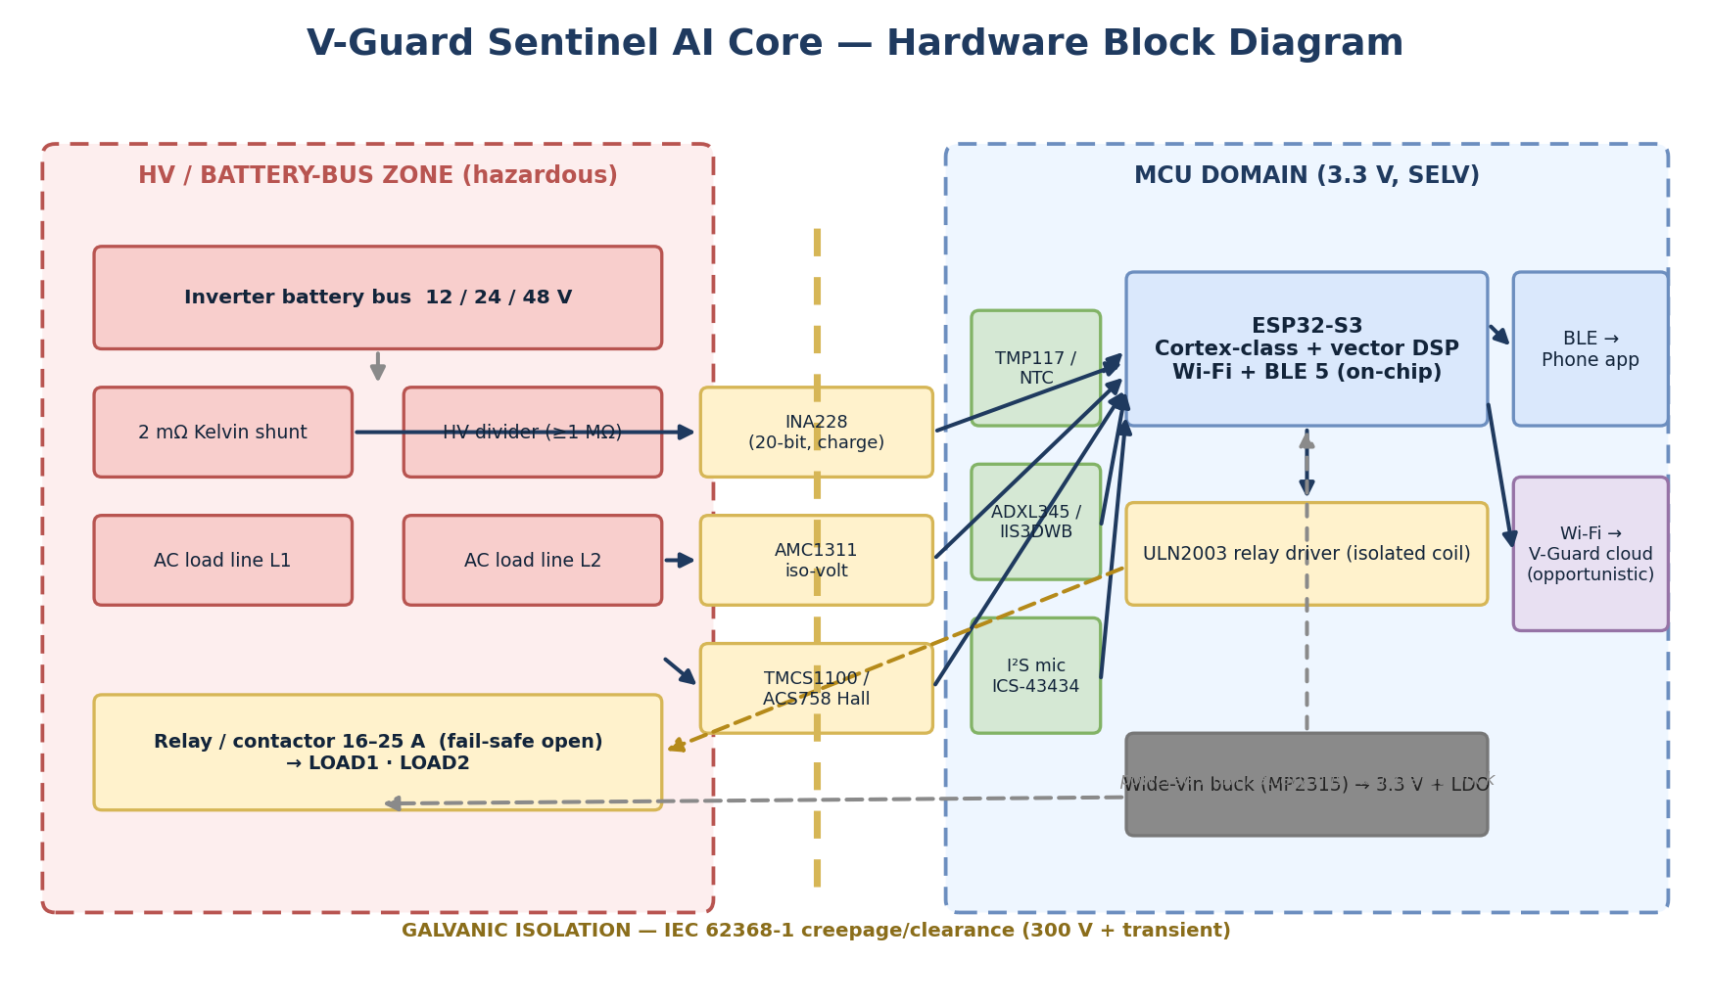
Exhibit 2. AI Core hardware block diagram. A galvanic-isolation barrier separates the hazardous battery-bus/HV zone from the SELV MCU domain; isolation ICs (INA228, AMC1311, TMCS1100) bridge it safely.
5.1 Compute
The workloads - a small recurrent or 1-D convolutional network for RUL, an autoencoder for anomalies, FFT-based power-quality analysis, and light load-monitoring - fit comfortably within TinyML budgets of tens of kilobytes at int8 precision. The cost-optimal choice is the Espressif ESP32-S3: dual vector-capable cores with integrated Wi-Fi and Bluetooth Low Energy on one part near 300 rupees, which eliminates a separate radio and its 200-to-400-rupee bill-of-materials line [30]. Where heavier models are wanted, an STM32N6 with a neural accelerator (about 600 GOPS) is the natural step-up, and an Ambiq Apollo4 at three microamps per megahertz suits an always-on, ultra-low-power node. Feature extraction uses the CMSIS-DSP library, where a 1024-point fixed-point FFT runs in roughly one millisecond on a Cortex-M4-class core [12], comfortably inside the ten-millisecond half-cycle window that power-quality work requires.
5.2 Isolated sensing front-end
Safety is the backbone of the design: everything touching the 150-to-300-volt battery bus or mains must be galvanically isolated from the microcontroller domain, and, critically, the 50-to-150-ampere battery current must never flow through the module's small PCB. Following the architecture of every commercial battery monitor - a separate high-current shunt or Hall sensor feeding a signal-only electronics head, exactly as in the Victron SmartShunt whose head (69 by 69 by 31 millimetres) is almost identical to our enclosure [32] - the Core reads current only as a low-level signal, taken from the inverter's existing shunt, or from an external 500-ampere / 50-millivolt (about 0.1-milliohm) busbar shunt, or from an ACS758 Hall sensor rated to plus-or-minus 200 amperes, through a 20-bit monitor with an on-chip charge accumulator (INA228; the 16-bit INA226 is the cost-tier option) that sees only tens of millivolts [30]. An ordinary split-core current transformer will not work, since transformers sense only alternating current; the direct-current battery line needs a busbar shunt or a Hall sensor. Bus voltage is sensed through a high-value divider into a reinforced isolation amplifier (AMC1311) via thin leads fused at one ampere at the battery terminal for safety. Temperature uses a battery-terminal NTC thermistor plus an optional 0.1-degree digital sensor (TMP117); a MEMS accelerometer (ADXL345, or the industrial IIS3DWB) and an I2S MEMS microphone (ICS-43434) capture vibration and acoustic fingerprints of relay, fan and transformer faults. For coulomb counting the binding constraint is not ADC resolution but current-sense offset, so the design periodically auto-zeros at true-zero-current windows and re-anchors state-of-charge against open-circuit voltage while the battery floats between outages.
5.3 Actuation, power and mechanical
Load shedding uses electromechanical relays or contactors rated 16 to 25 amps, chosen for low cost and a fail-safe galvanic open, driven by a ULN2003 array through isolated coils; solid-state relays are reserved for cases needing fast, frequent switching. A wide-input synchronous buck converter (MP2315-class) taps the inverter's existing rail to produce a 3.3-volt supply with a microamp-class quiescent budget, so the module never meaningfully loads the battery. The mechanical package is a flame-retardant PC/ABS enclosure rated UL94 V-0, roughly 90 by 70 by 35 millimetres - the extra height over a minimal board giving relay and connector clearance - housing an 80-by-60-millimetre PCB with four M3 mounting points, indoor IP20 rating, DIN-rail or adhesive mounting, and segregated screw terminals that carry only signal and relay-drive lines (not main current) plus JST connectors for low-voltage leads (Exhibit 3). The module mounts on or beside the inverter chassis, which has ample room in its roughly 275-by-250-by-120-millimetre envelope, and never on the 40-to-65-kilogram floor-standing battery; high-current load circuits are switched by external contactors driven from the module, so that current too stays off the PCB.
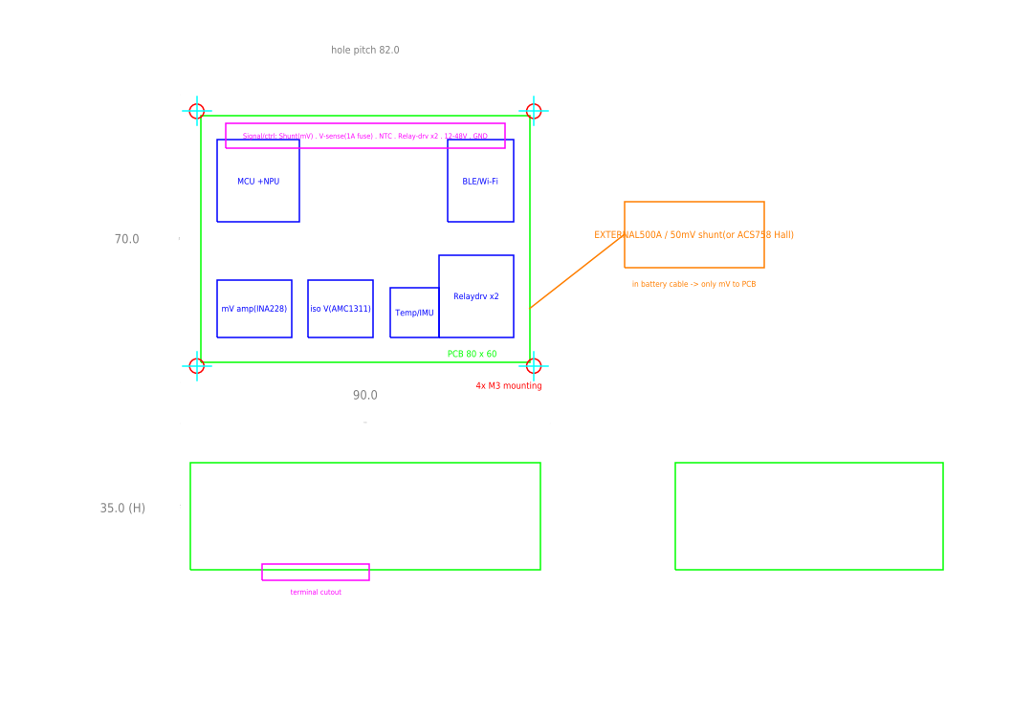
Exhibit 3. Sentinel AI Core enclosure and PCB - dimensioned CAD multiview (top, front, side). Editable AutoCAD sources (DXF, parametric AutoLISP, script) are provided in the CAD folder.
5.4 Cost: the incremental-versus-standalone reality
An itemised bill of materials (Exhibit 15) shows a basic standalone board at approximately 600 rupees and a full premium board at around 3,300 rupees, the latter driven by the industrial vibration sensor and the isolation chain. The headline target of 150 to 800 rupees of added cost is realistic as an incremental cost over an inverter that already carries a shunt, relays, a microcontroller and a power rail - which metering-capable inverters do - because those parts are then shared. As a standalone retrofit, the honest figure is about 600 rupees for the basic variant; a premium standalone can be brought under 800 rupees by using an accelerometer instead of the industrial vibration sensor, a Hall sensor instead of the isolated voltage chain, and the host's relay. Stating this openly is deliberate: an over-optimistic single number would not survive expert scrutiny, whereas the incremental-cost argument is both true and strategically stronger.
6. Engine 1: Predictive Battery Health and Remaining Useful Life
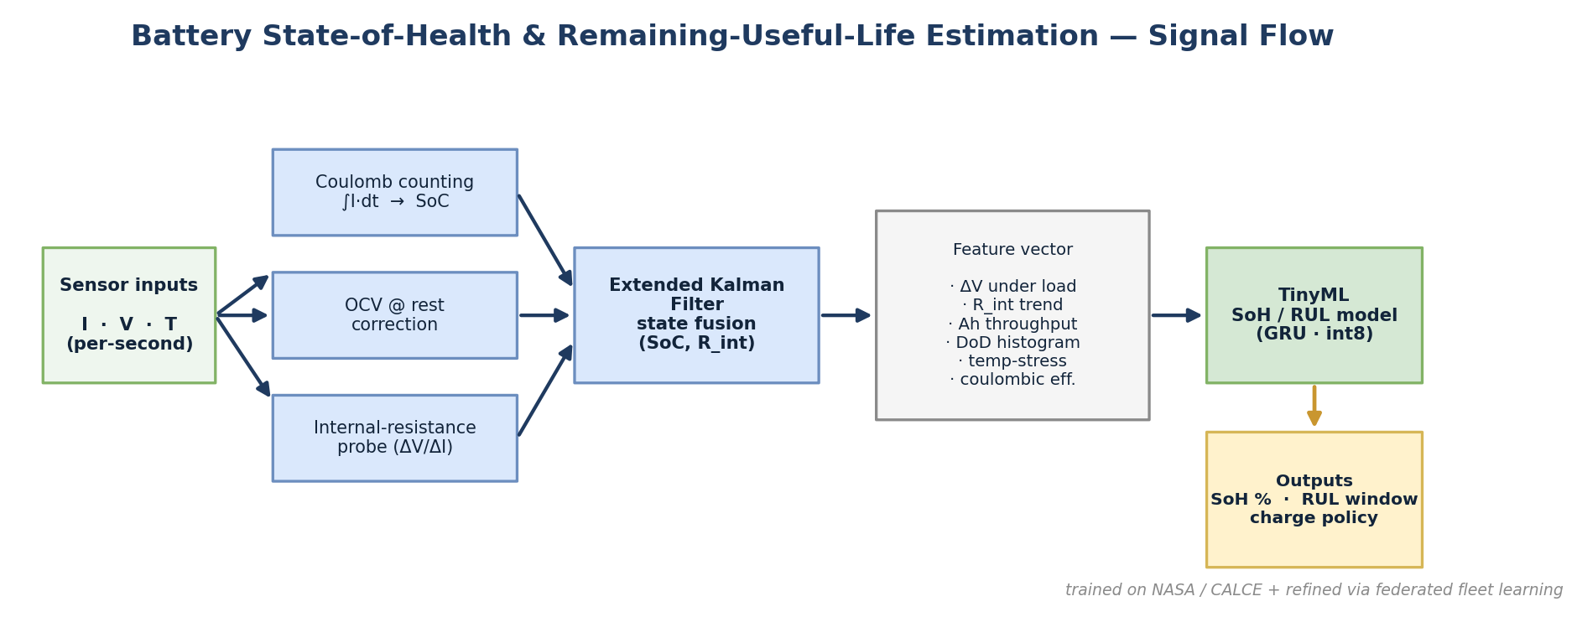
Exhibit 4. Battery SoH/RUL signal flow: coulomb counting, OCV correction and an internal-resistance probe are fused by an Extended Kalman Filter into a feature vector consumed by a compact TinyML model.
6.1 Estimation stack
Sentinel fuses classical estimation with a small learned corrector. Coulomb counting integrates current for a fast state-of-charge estimate but drifts because it integrates sensor bias open-loop; a 0.5% current bias can produce several percent of drift per week. Rested open-circuit voltage and a DC-pulse internal-resistance probe correct it, and an Extended Kalman Filter fuses these into a bounded state, an approach that is mainstream in production battery management and reports state-of-charge RMSE around one percent [8][9] (Exhibit 6). Lead-acid has a usefully sloped open-circuit curve, so voltage anchoring works well; lithium-iron-phosphate's flat plateau makes it harder, an asymmetry the design accounts for. A feature vector - voltage sag under load, internal-resistance trend, ampere-hour throughput, depth-of-discharge histogram, temperature-stress integral and coulombic efficiency, plus incremental-capacity peaks from the partial charge that follows each outage - feeds a compact quantised model that maps feature history to state-of-health and an RUL window.
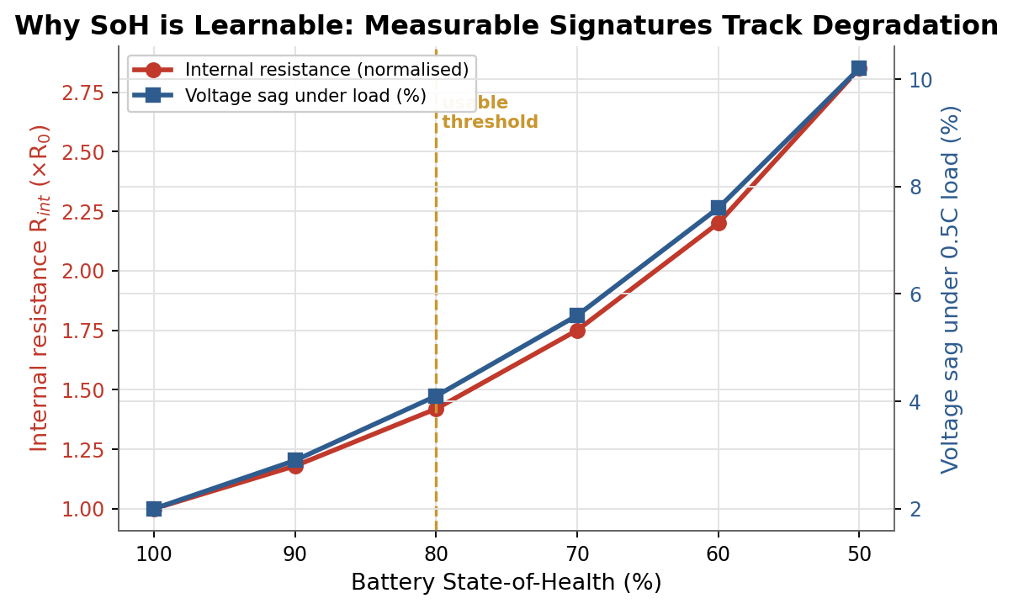
Exhibit 5. Why state-of-health is learnable: internal resistance and voltage-sag-under-load both track degradation measurably as capacity falls toward the 80% usable threshold.
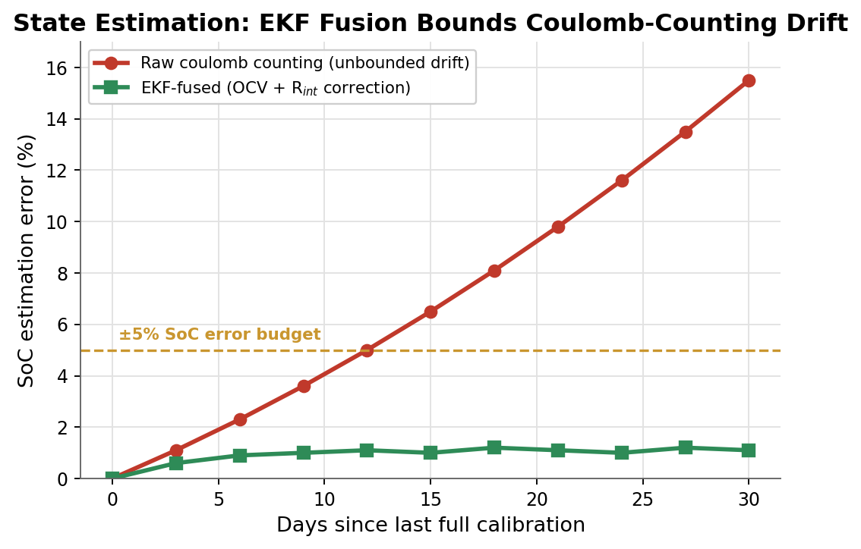
Exhibit 6. State estimation: an Extended Kalman Filter bounds the open-loop drift of raw coulomb counting within a +/-5% state-of-charge budget by fusing open-circuit-voltage and internal-resistance corrections.
6.2 Data strategy and the lead-acid gap
We are candid about a real limitation: rigorous, benchmarked machine-learning results for battery health are almost all on lithium-ion laboratory cells, drawing on public datasets such as NASA's Prognostics Center of Excellence set, CALCE, Oxford and Sandia [7][8][9][10]; there is essentially no canonical open lead-acid degradation dataset. For a tubular-battery product we will therefore run our own accelerated aging campaign - logging partial charge curves, DC internal resistance, charge acceptance, temperature, throughput and depth-of-discharge histograms - and use the abundant lithium-ion data for architecture prototyping and transfer learning rather than direct parameter reuse. V-Guard's in-house battery manufacturing and reliability lab make this aging campaign uniquely practical, and it is itself a defensible moat: the data does not exist to be bought.
The aging campaign is a concrete, ownable programme rather than a hope. A representative matrix of tubular cells is cycled across the temperature, depth-of-discharge and charge-rate combinations that characterise Indian use, instrumented for partial-charge curves, DC internal resistance and charge acceptance, until each reaches the eighty-percent end-of-life threshold. Lithium-ion public datasets seed the model architecture and feature engineering, and transfer learning adapts the pretrained network to lead-acid with far less data than training from scratch would need. Because V-Guard manufactures the cells and runs a reliability lab, this data - the true scarce asset in battery prognostics - is generated in-house and continually enriched by the fleet, compounding the moat described in Section 9.
6.3 On-device feasibility
On-microcontroller inference is well within reach. TensorFlow Lite Micro needs only tens of kilobytes [11], and a published battery-RUL model has run in 11 kilobytes of flash and 1.2 kilobytes of RAM with two-millisecond inference on a sub-dollar Cortex-M0-plus core [13]; CMSIS-NN gives a further four-to-five-times speed and energy improvement on Cortex-M parts [12]. Because health updates once per charge or per hour, latency is irrelevant; the binding constraints are sensing quality and training data, not compute. Reported state-of-health error is roughly one-to-two percent on clean lithium-ion benchmarks and around five percent on-device after quantisation, and coarser for data-limited lead-acid - numbers we quote as ranges, not as marketing absolutes.
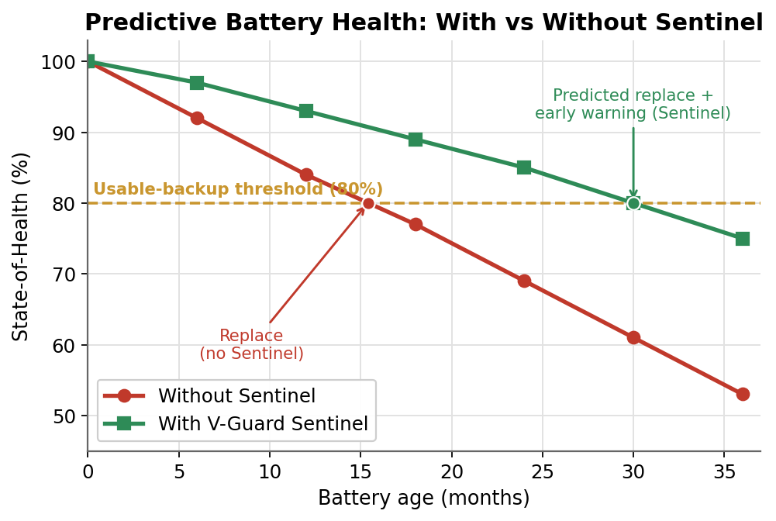
Exhibit 7. Predictive battery health: Sentinel's charge and thermal policy keeps state-of-health above the usable threshold longer, and forecasts the replacement window weeks ahead.
6.4 Honest lead-time framing
The strongest published evidence, on lithium-iron-phosphate cells under controlled cycling, predicts total life from the first hundred cycles at about nine percent error [7]. But three hard limits must be stated. The capacity fade 'knee' is a fundamental barrier, and nominally identical cells diverge widely. RUL is path-dependent on future usage that cannot be seen in advance, so irregular Indian inverter duty will be noisier than the lab. And certain faults - internal shorts, corrosion open-circuits, thermal runaway - are event-driven and not predictable from voltage, current and temperature trends. Sentinel therefore advertises a degradation-trend warning, not a safety-event prediction: it reports state-of-health with an uncertainty band, issues a graded early warning - healthy, degrading, or replace within N weeks - months ahead for gradual wear, and raises anomaly flags for fast faults. This honesty is a feature, because a warning window the installer can trust beats a false-precision date that discredits the product on its first miss.
7. Engine 2: Habit-Learning Autopilot and Load Prioritisation
Load prioritisation is mature but, tellingly, everything shipped commercially - from Tesla Powerwall's essential-circuit logic to smart-panel products - is rule-based on state-of-charge, voltage or frequency thresholds; fully learned, reinforcement-driven control is still a research result with simulation-inflated numbers, and it is entirely absent from Indian home inverters [31]. Sentinel therefore ships a defensible hybrid: robust rule-based tiers made smarter by a learned demand-and-outage forecaster. On outage detection the autopilot estimates available energy as state-of-health times state-of-charge times capacity, forecasts demand and likely outage duration from patterns it has clustered on-device, tiers loads into keep (refrigerator, lights, Wi-Fi, medical), defer (geyser, pump) and shed (air-conditioner), actuates relays to protect the keep tier, and continuously re-evaluates until the grid restores, then recharges optimally (Exhibit 8). Realistic gains are of the order of ten to twenty percent of usable backup for essentials, not the sixty-percent figures seen in simulation-only papers. Fail-safe defaults ensure a sensor or model fault never strands critical loads.
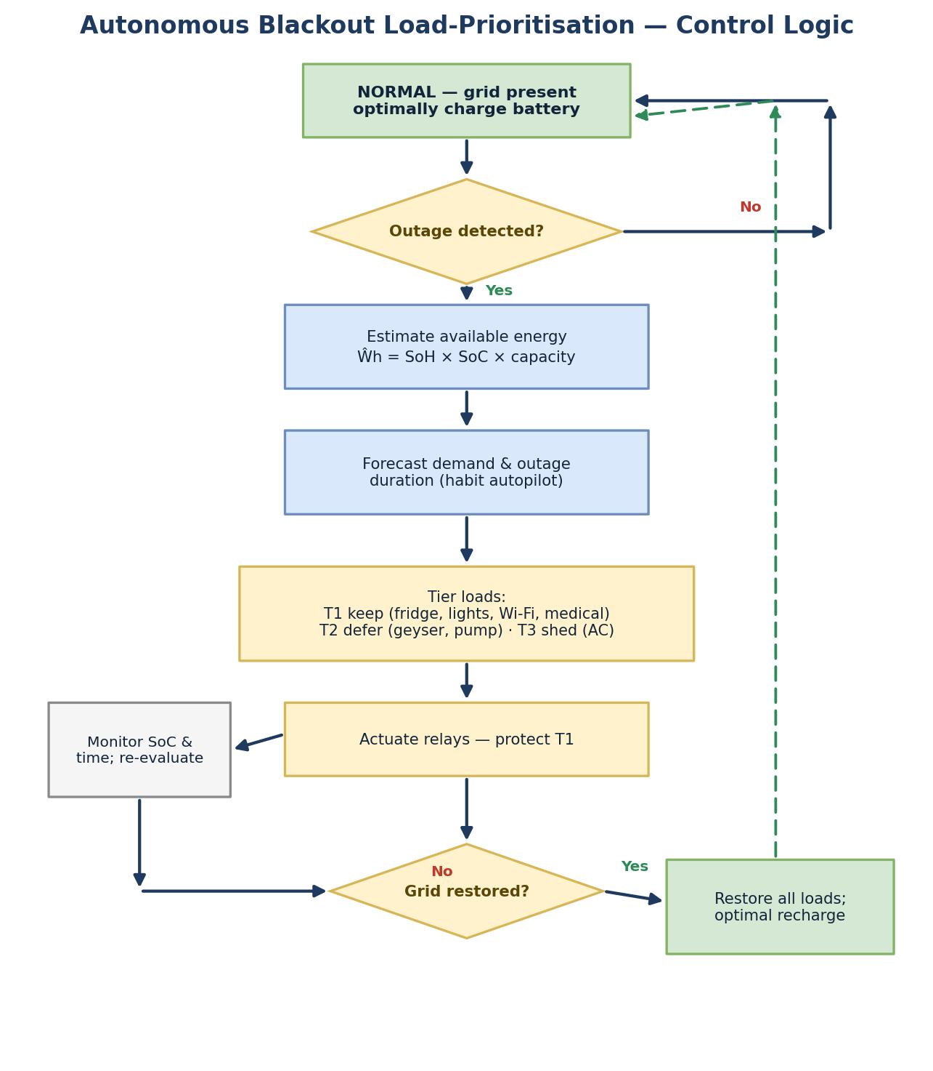
Exhibit 8. Autonomous blackout load-prioritisation control logic: a rule-based tiering core informed by a learned demand and outage-duration forecaster.
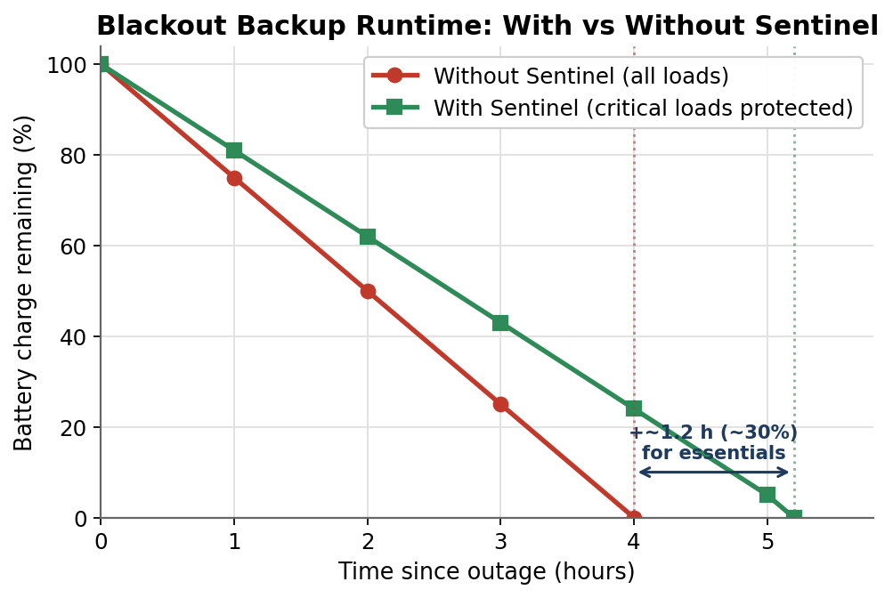
Exhibit 9. Blackout backup runtime: by protecting critical loads and shedding the rest, Sentinel extends usable backup for essentials during an outage.
8. Engine 3: Energy Coach and Grid Shield
The Energy Coach uses non-intrusive load monitoring to disaggregate consumption. We scope it honestly: low-frequency disaggregation reliably separates high-power loads such as air-conditioners, geysers, pumps and refrigerators at roughly 0.65 to 0.89 F-score on benchmark datasets [20], but low-power and overlapping loads and cross-home generalisation are known weaknesses, and the only public Indian dataset is a single Delhi home [21]. Sentinel therefore positions the Coach as directional insight with per-home calibration for headline loads, treating fine-grained disaggregation as a cloud-assisted roadmap item - valuable as time-of-use tariffs arrive with the national smart-meter rollout [29], and never over-claimed. The Grid Shield is scoped with equal care. Grid-origin voltage sags propagate almost instantly and have no locally observable precursor, so the honest capability is fast detection and ride-through response, not prediction: using RMS and FFT the Core detects a sag within about one cycle and protects or annotates accordingly, targeting an IEC 61000-4-30 Class-S-like measurement rather than a certified Class-A instrument [18][19]. Only a self-caused local motor start is genuinely anticipatable; seasonal and statistical risk is advisory only. Claiming detection rather than prediction is exactly the kind of precision expert judges reward.
9. Engine 4: Federated Fleet Intelligence
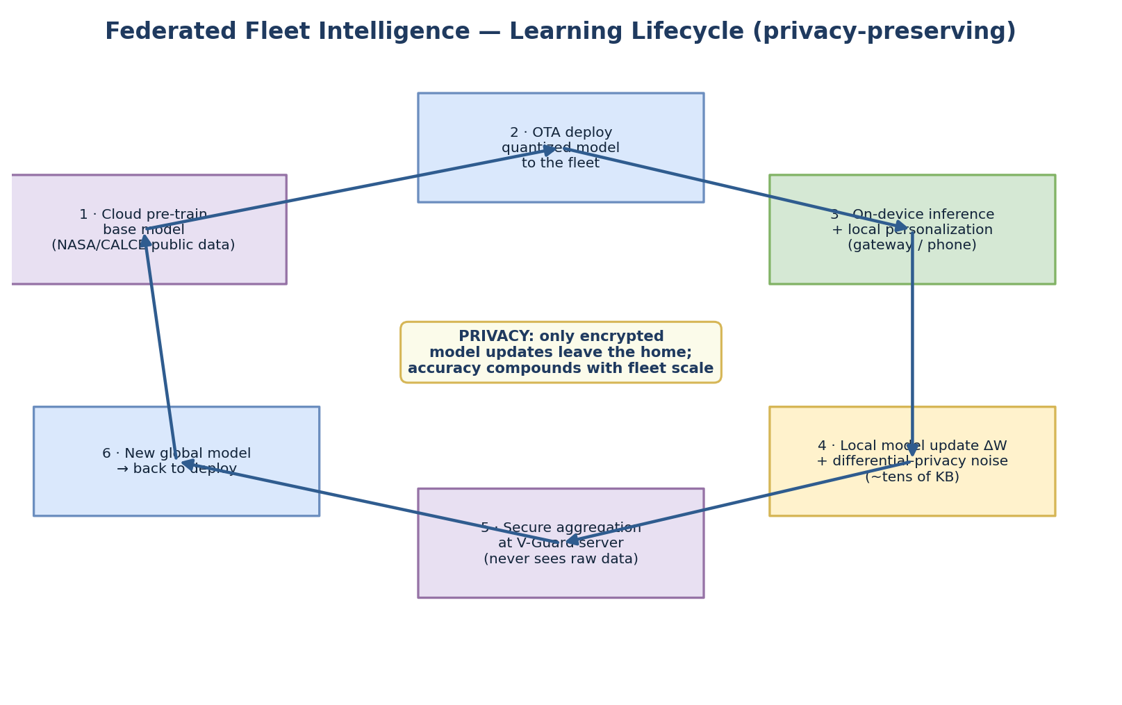
Exhibit 10. Federated learning lifecycle: cloud pre-training, OTA deployment, on-device inference with gateway/phone-tier local training, differentially-private updates, and secure server-side aggregation.
The moat is a self-improving fleet, but we describe a deployable pipeline rather than hype. Training deep models directly on the inverter microcontroller across a fleet is not realistic today; at most, sparse on-device fine-tuning of a fixed model is feasible, as demonstrated by on-device training under 256 kilobytes of memory [17]. The honest architecture is: the microcontroller runs quantised inference continuously; a home gateway or the owner's paired phone performs the actual local training round, because it has the memory, floating-point unit and reliable power; only model deltas of tens to hundreds of kilobytes are uploaded opportunistically when power and connectivity allow; and a V-Guard server aggregates them with FedAvg or DP-FTRL into an improved global model that is pushed on the next update window. We use the Flower framework, which is built for exactly this intermittent, framework-agnostic deployment [14]. Privacy is handled properly: because model updates can leak training data through gradient inversion, Sentinel combines Secure Aggregation, so the server sees only the summed update [15], with Differential Privacy, the production technique behind large-scale federated keyboards [16]. We are candid that privacy strengthens with cohort size, so early-pilot guarantees are modest and tighten as the fleet grows - which is also the moat: accuracy and privacy both compound with V-Guard's installed base, something no competitor can rebuild without the same scale (Exhibit 11).
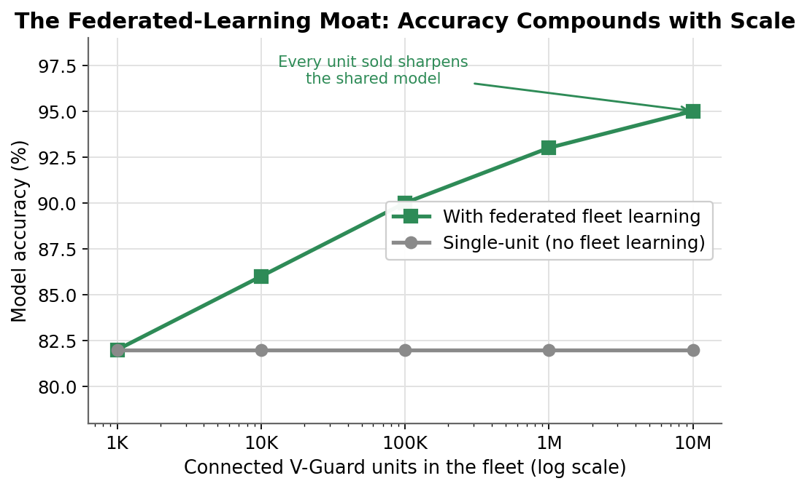
Exhibit 11. The federated-learning moat: model accuracy compounds as the installed base grows, an advantage competitors cannot buy.
The communication budget makes this practical at fleet scale. A TinyML model of tens to hundreds of kilobytes yields updates of similar size, so a device participating roughly once a day imposes negligible bandwidth, and the protocol tolerates the asynchronous, intermittent participation a real Indian fleet exhibits. The largest production precedent, a federated mobile keyboard trained across millions of devices with formal differential-privacy guarantees, shows that this pattern - opportunistic, privacy-bounded and server-aggregated - already works at national scale, which de-risks the approach for V-Guard rather than requiring it to be invented [16].
10. Key Parameters and Performance Targets
The design is specified by the parameters in Exhibit 14, spanning electrical sensing, computation, machine-learning thresholds, the federated protocol, product-level targets and the operating environment. These values define acceptance criteria for the prototype and the production module, and are the quantities the Phase-4 build will validate against.
11. Prototype and Validation Plan
Matching our team's machine-learning and full-stack strengths, the prototype is software-led. We will train a battery-RUL model on NASA and CALCE data augmented with synthetic Indian tubular duty cycles and report mean-absolute error, root-mean-square error and calibration of the predicted failure window on held-out cells. We will run a federated-learning simulation in Flower across at least five simulated homes, demonstrating that the shared model improves while no raw data leaves a client, with Secure Aggregation and Differential Privacy enabled. A dashboard application will visualise state-of-health, the RUL countdown, the autonomous load-prioritisation simulation and energy insights. As an optional hardware demonstration, the quantised RUL model will be flashed to an ESP32-S3 with a current-sensor breadboard to prove genuine on-device inference without any custom PCB or manufacturing. The CAD package in this submission (DXF, AutoLISP and script) visualises the physical module. Success is measured by RUL-window hit-rate, state-of-charge error within five percent, load-shed correctness, federated accuracy relative to a centralised baseline, and on-device latency and footprint. Prototype images and videos will be shared via a linked folder: [insert Google Drive link].
Each demonstration maps deliberately to a marked criterion. The RUL model and its calibration evidence the novelty of the solution and the appropriateness of the supporting technology; the federated simulation evidences both the privacy design and the compounding moat; and the on-device inference demonstration, together with the bill of materials and CAD package, evidences feasibility. We will publish the evaluation methodology and the held-out results so that the numbers can be checked rather than taken on trust, consistent with the honesty that runs through the whole design.
12. Standards, Safety and Compliance
The mandatory Indian gate for the electronics is BIS certification under IS/IEC 62368-1, which is replacing IS 13252 Part 1 for information and communication technology equipment [22]; the host inverter remains under IEC 62040 for uninterruptible power systems [23], and the module must not degrade the host's compliance. Electromagnetic compatibility and immunity follow the IEC 61000 family, including electrostatic-discharge, radiated-immunity and surge tests, with power-quality measurement performed to an IEC 61000-4-30 Class-S-like level [18]. Any lithium cell on the module falls under IS 16046-2 and IEC 62133-2 [24]. RoHS and, for export, CE marking under the Low-Voltage and EMC directives apply. Isolation on all mains-referenced sensing, creepage and clearance designed for 300 volts plus transients, fused sense taps, transient suppression on the high-voltage node, and fail-safe relay defaults are core safety requirements. Notably, home inverters, batteries and stabilisers currently carry no BEE energy-star label, an open efficiency-differentiation niche Sentinel can help V-Guard lead.
13. Feasibility and Manufacturing
Sentinel is a software-led upgrade to products V-Guard already builds at scale, so the path to revenue is short: new inverters embed the Core on the main board, and the installed base is addressed by the retrofit module. The bill of materials sits within a single-digit-to-low-double-digit-percent price premium when integrated. V-Guard's in-house battery manufacturing lets health models be co-designed with the cell chemistry - an advantage a third-party add-on cannot match - and the Kochi reliability lab provides the validation and aging-campaign infrastructure the data strategy requires. Because the compute, sensing and machine-learning building blocks are all commercially proven and individually cited above, the technical risk is integration and data, not invention.
Physically, the module is a signal-and-control unit that mounts on or beside the inverter and senses the battery through an external shunt or Hall sensor, so the 50-to-150-ampere battery current never crosses its PCB - the same split used by mass-produced battery monitors, and validated here against real V-Guard battery and inverter dimensions (Exhibit 12).
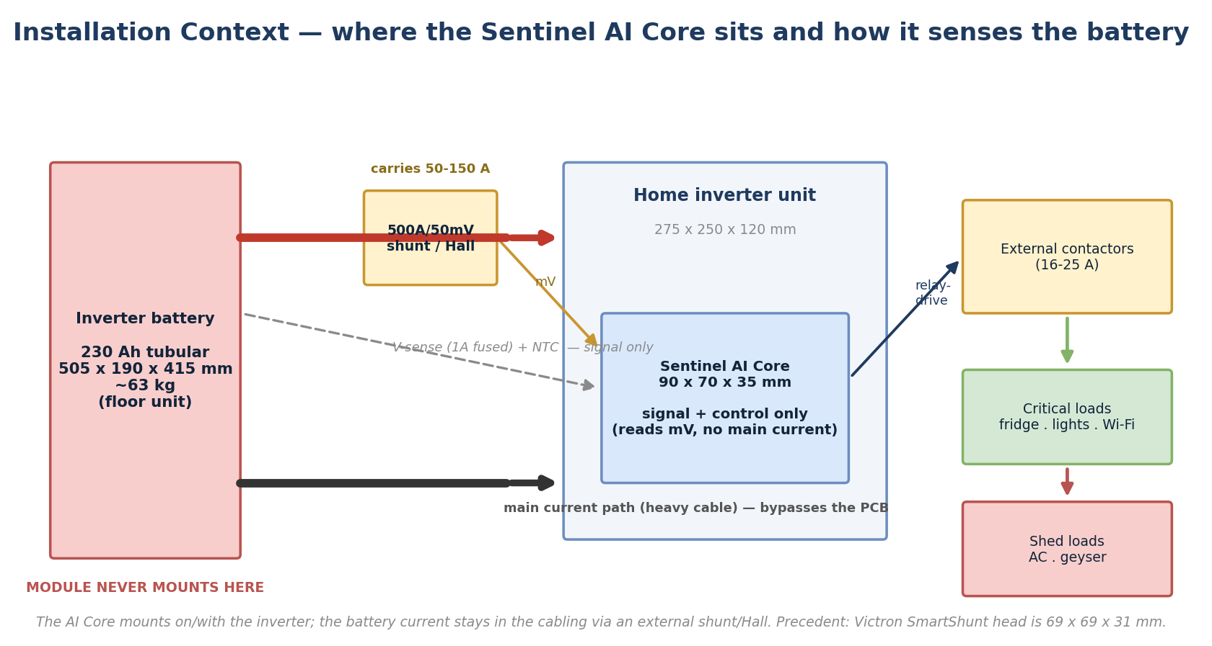
Exhibit 12. Installation context: the AI Core mounts with the inverter and senses the 505 x 190 x 415 mm, ~63 kg battery through an external 500A shunt or Hall sensor; only millivolt signals reach the PCB, and high-current loads are switched by external contactors.
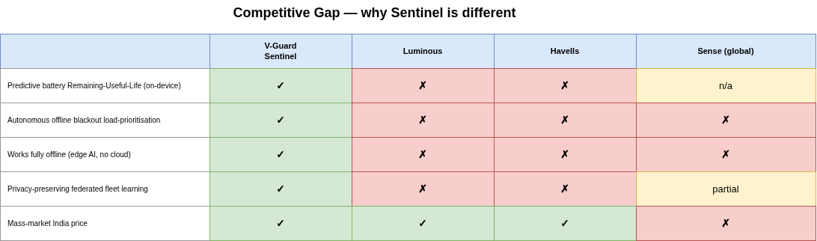
Exhibit 13. Competitive gap: Sentinel is the only proposition that is simultaneously predictive, autonomous, offline-first and self-improving at mass-market cost.
14. Business Value and Market Opportunity
India's home-UPS market is about 348 million dollars in 2024, growing to roughly 487 million by 2030; the inverter-battery market is on the order of 197 million dollars growing above six percent annually; stabilisers and geysers add further multi-hundred-million-dollar, mid-single-digit-growth markets [26][27]. V-Guard already sells across all of these through more than 100,000 retail touchpoints, so the addressable base for a software-led upgrade is enormous, and the national smart-meter rollout with time-of-use tariffs creates demand for exactly the energy optimisation Sentinel provides [29]. The value compounds for V-Guard in four ways. First, recurring, perfectly-timed aftermarket revenue: predicting the replacement window prompts the next battery purchase from V-Guard at the right moment, converting a one-time sale into a managed lifecycle. Second, warranty and service savings: V-Guard's warranty cost was about 1.52% of revenue, roughly 69 crore rupees in one recent year [25], and predictive maintenance converts emergency claims into planned interventions while defending against avoidable, warranty-voiding failures such as electrolyte neglect. Third, retention, premiumisation and a data moat that deepens with every unit through federated learning. Fourth, portfolio leverage, as one AI Core extends to pumps, stabilisers and water heaters.
A worked example makes the economics concrete. If Sentinel moves even a fraction of battery replacements back to V-Guard at the moment of genuine end-of-life, and converts a share of emergency warranty claims into planned, correctly-attributed service, the margin recovered across a base of many millions of units dwarfs the few-hundred-rupee incremental cost of the Core. In effect the product pays for itself out of warranty savings and aftermarket capture alone, before any premium pricing or cross-portfolio leverage is counted - which is why the business case does not depend on charging the consumer more.
15. Sustainability and Social Impact
Extending battery life by 15 to 30% and pinpointing replacement reduces premature disposal of lead-acid batteries - significant because an estimated 60 to 80% of India's used-lead-acid recycling is informal, and lead exposure already affects an estimated 275 million Indian children [28]. Optimised charging cuts wasted energy; predictive maintenance extends product lifespans across the portfolio and reduces material consumption. For price-sensitive and rural homes, resilient, self-managing backup protects food, study hours, connectivity and medical devices through the outages that remain a daily reality [1][2]. Sustainability here is not a bolt-on; it is a direct consequence of making the product predict, optimise and last.
16. Competitive Differentiation
Against Luminous and Microtek, whose 'smart' inverters are app-monitoring with rule-based charging, Havells and Su-Kam with no predictive layer, and Western energy-AI players that are cloud-dependent, premium and largely absent from or exiting the Indian consumer market, Sentinel is the only offering that is simultaneously predictive, autonomous, offline-first and self-improving through federated learning at mass-market cost (Exhibit 13). No mainstream Indian inverter ships machine-learning battery-failure prediction, autonomous offline load-prioritisation, or federated fleet learning; these three together are the novelty.
17. Risks and Mitigations
The principal risk is over-claiming, which we mitigate by scoping every engine to the deployed-versus-research boundary and reporting windows and ranges rather than false precision. Model generalisation across chemistry, climate and home is addressed by our own aging campaign, federated refinement and per-home calibration with conservative confidence bounds. Privacy risk is met with Secure Aggregation and Differential Privacy and honestly modest early claims. Cost creep is controlled by the tiered bill of materials and reuse of existing sensing. Safety risk is met with isolation, fail-safe relay defaults, standards compliance and reliability-lab validation. In each case the mitigation is specific and, where possible, cited.
18. Roadmap and Vision
Phase 1, over zero to six months, delivers Sentinel's battery-RUL and autopilot engines in the Smart-Pro inverter line with a federated-learning pilot. Phase 2, over six to eighteen months, adds the Energy Coach and Grid Shield and offers the AI Core as a retrofit module for the installed base. Phase 3, over eighteen to thirty-six months, rolls the platform out across pumps, stabilisers and water heaters, coordinated as one intelligent home. The vision is that by 2030 every V-Guard product in a home runs on one shared AI Core, operating not as separate appliances but as a single self-aware system that predicts its own failures, manages the home's power, and keeps essentials running through any outage without the user thinking about it. Because every unit shipped feeds the same models through federated learning, scale itself becomes an advantage rivals cannot rebuild, and V-Guard becomes the intelligence layer the Indian home runs on.
Exhibit 14. Key parameters and performance targets
Parameter | Target / range
Battery current sensing | EXTERNAL 500A/50mV (~0.1 mΩ) busbar shunt or ACS758 Hall (±200A); INA226/228 reads mV only — main current never on the PCB; auto-zero offset
Isolated voltage sensing | 150–300 V via divider + reinforced isolation (AMC1311); thin sense leads FUSED 1A at terminal; ±5–10 mV (lead-acid)
Temperature | Battery-terminal NTC; optional ±0.1 °C digital (TMP117); operating 0–55 °C
Enclosure & mounting | ~90 × 70 × 35 mm, PC/ABS UL94 V-0, IP20; mounts on/with the inverter (NOT the battery); high-current loads via external contactors
Compute / model | ESP32-S3 class; TinyML int8 models 5–100 KB; inference <10 ms; RAM <2 KB
SoC estimation | Coulomb count + OCV + EKF; error budget ±5%
SoH usable threshold | 80% of rated capacity (end-of-life convention)
RUL output | State-of-health with uncertainty band; graded warning 'replace within N weeks'
Load tiers | T1 keep (fridge, lights, Wi-Fi, medical) · T2 defer (geyser, pump) · T3 shed (AC)
Power-quality | RMS + FFT; 128–256 samples/cycle; IEC 61000-4-30 Class-S-like; ~1-cycle detection
Federated protocol | Opportunistic ~daily rounds; delta 10s–100s KB; Secure Aggregation + Differential Privacy
Product targets | Battery-life extension 15–30%; backup extension ~10–20% for essentials; module idle µA-class
Compliance | IS/IEC 62368-1; IEC 62040 (host); IEC 61000 EMC; IS 16046-2 (if Li cell); RoHS/CE
Exhibit 15. Illustrative bill of materials (basic variant; premium detailed in hardware notes)
Item (Basic variant) | Approx. INR
ESP32-S3 module (Wi-Fi + BLE) | 250
INA226 + 10 mΩ shunt (DC current/charge) | 60
ACS712 Hall (AC load current) | 40
2× NTC temperature | 15
ADXL345 accelerometer | 30
16 A relay + ULN2003 driver | 55
Wide-Vin buck (3.3 V) | 45
UL94 V-0 enclosure | 60
Connectors + passives | 45
BASIC standalone total (≈) | ~600
Incremental cost if host sensing/relay/MCU shared | ~150–300
References
[1] LocalCircles, India Power Outage Survey, 2023.
[2] Council on Energy, Environment and Water (CEEW), India Residential Energy Survey (IRES), 2020.
[3] Prayas (Energy Group), Quality of Electricity Supply in India, 2023.
[4] P. Ruetschi, 'Aging mechanisms and service life of lead-acid batteries,' Journal of Power Sources, 127 (2004) 33-44.
[5] J. Vetter et al., 'Ageing mechanisms in lithium-ion batteries,' Journal of Power Sources, 147 (2005) 269-281.
[6] Battery University, BU-806a: How Heat and Loading Affect Battery Life.
[7] K. A. Severson et al., 'Data-driven prediction of battery cycle life before capacity degradation,' Nature Energy, 4 (2019) 383-391.
[8] NASA Prognostics Center of Excellence (PCoE), Battery Data Set Repository.
[9] CALCE Battery Research Group, University of Maryland, Battery Data.
[10] Sandia National Laboratories cycling dataset, batteryarchive.org.
[11] R. David et al., 'TensorFlow Lite Micro,' arXiv:2010.08678, 2020.
[12] L. Lai, N. Suda, V. Chandra, 'CMSIS-NN: Efficient Neural Network Kernels for Arm Cortex-M,' arXiv:1801.06601, 2018.
[13] On-microcontroller battery RUL estimation (TinyML), Sensors, 2024.
[14] D. J. Beutel et al., 'Flower: A Friendly Federated Learning Framework,' arXiv:2007.14390, 2020.
[15] K. Bonawitz et al., 'Practical Secure Aggregation for Privacy-Preserving Machine Learning,' ACM CCS, 2017.
[16] Google Research, 'Federated Learning with Formal Differential Privacy Guarantees (DP-FTRL),' 2022; arXiv:2305.18465.
[17] J. Lin et al., 'On-Device Training Under 256KB Memory (MCUNetV3),' NeurIPS, 2022; arXiv:2206.15472.
[18] IEC 61000-4-30, Testing and measurement techniques - Power quality measurement methods.
[19] IEEE Std 1159, Recommended Practice for Monitoring Electric Power Quality.
[20] C. Zhang et al., 'Sequence-to-point learning for non-intrusive load monitoring,' AAAI, 2018.
[21] N. Batra et al., iAWE: India Appliance-level energy dataset.
[22] IS/IEC 62368-1:2023, Audio/video, information and communication technology equipment - Safety.
[23] IEC 62040, Uninterruptible power systems (UPS).
[24] IS 16046-2 / IEC 62133-2, Secondary lithium cells and batteries - Safety.
[25] V-Guard Industries Ltd, FY2026 Financial Results and investor communications.
[26] MarketsandMarkets, India Home UPS / Inverter Market report.
[27] IMARC Group, India Inverter Battery Market report.
[28] Pure Earth, India Lead Exposure / Global Lead Program.
[29] Ministry of Power, Revamped Distribution Sector Scheme (RDSS) smart-metering status, 2025-26.
[30] Texas Instruments INA228, AMC1311, TMCS1100; Espressif ESP32-S3 datasheets.
[31] Tesla Powerwall and smart-panel product documentation (essential-load prioritisation).
[32] Victron Energy SmartShunt / BMV-712 battery-monitor documentation (500A/50mV shunt architecture); Allegro ACS758 Hall current-sensor datasheet.

